4.Create-react-app tool with the name as “blogapp”

Step1:Creating the React App and navigating in the folder

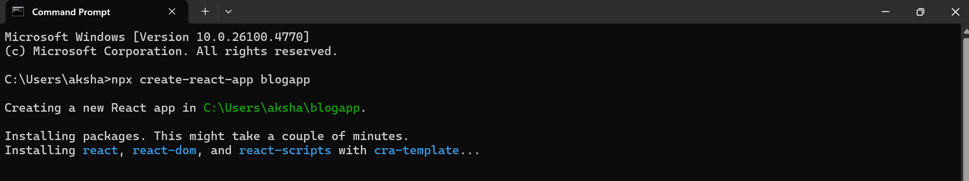

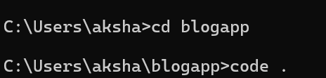

Step2:Creating Post.js and modifying it

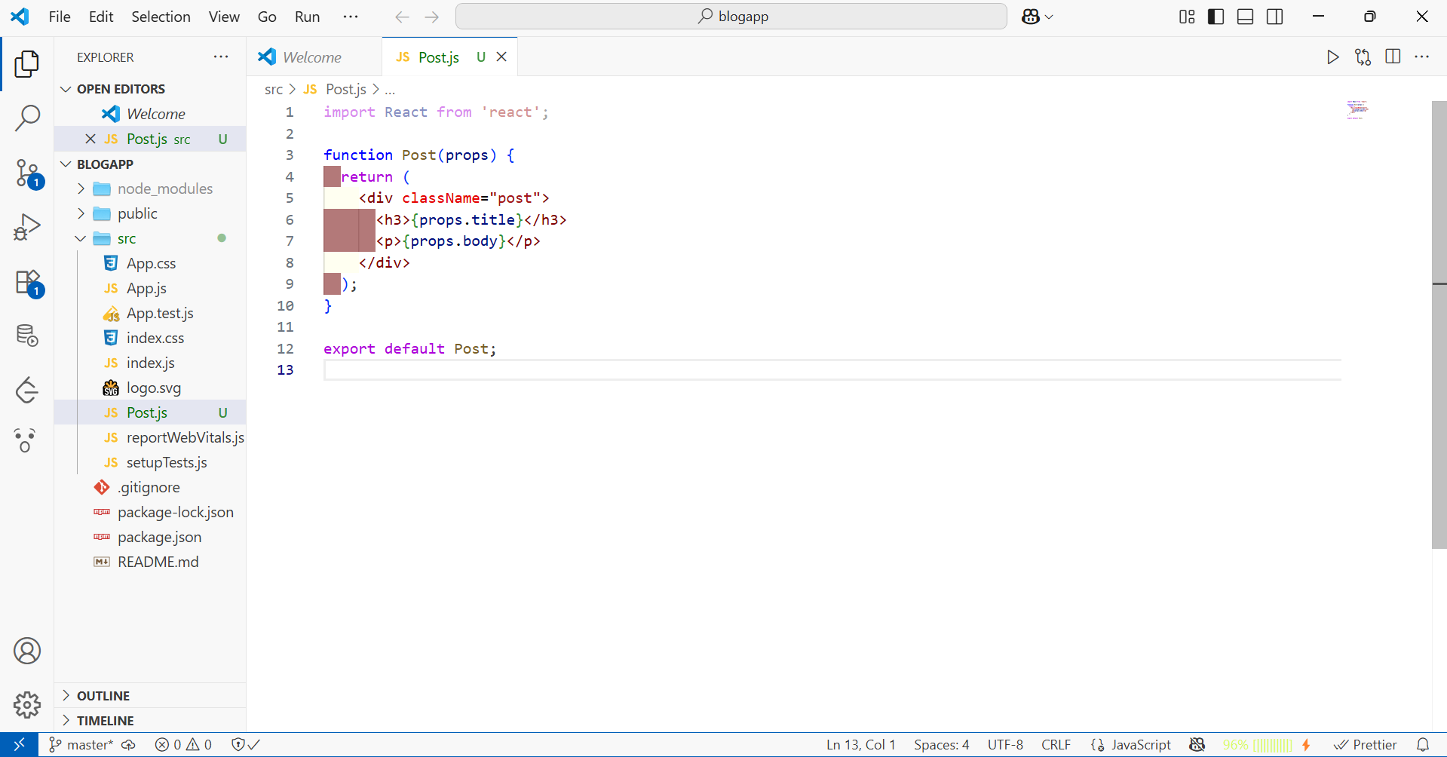

Step3:Creating Posts.js and modifying it

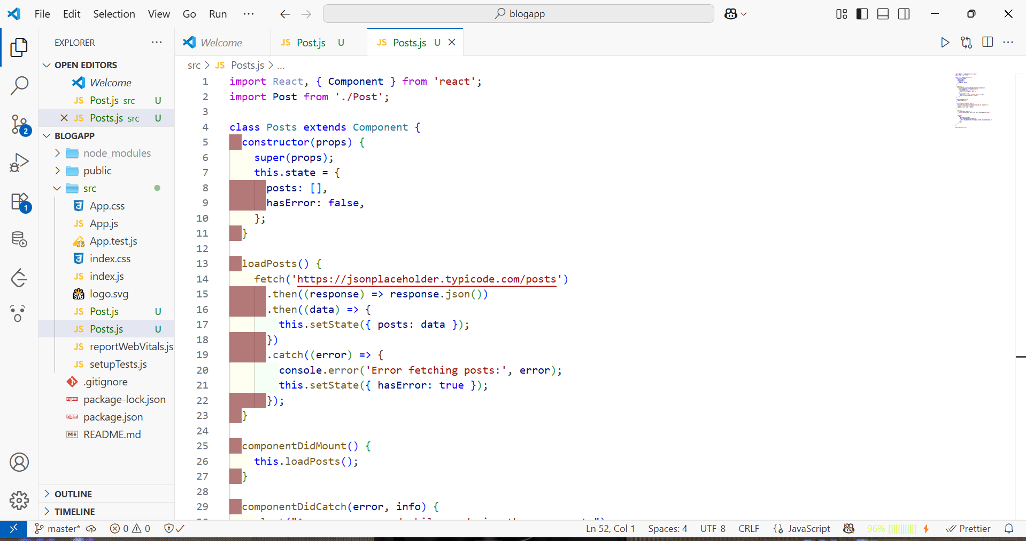

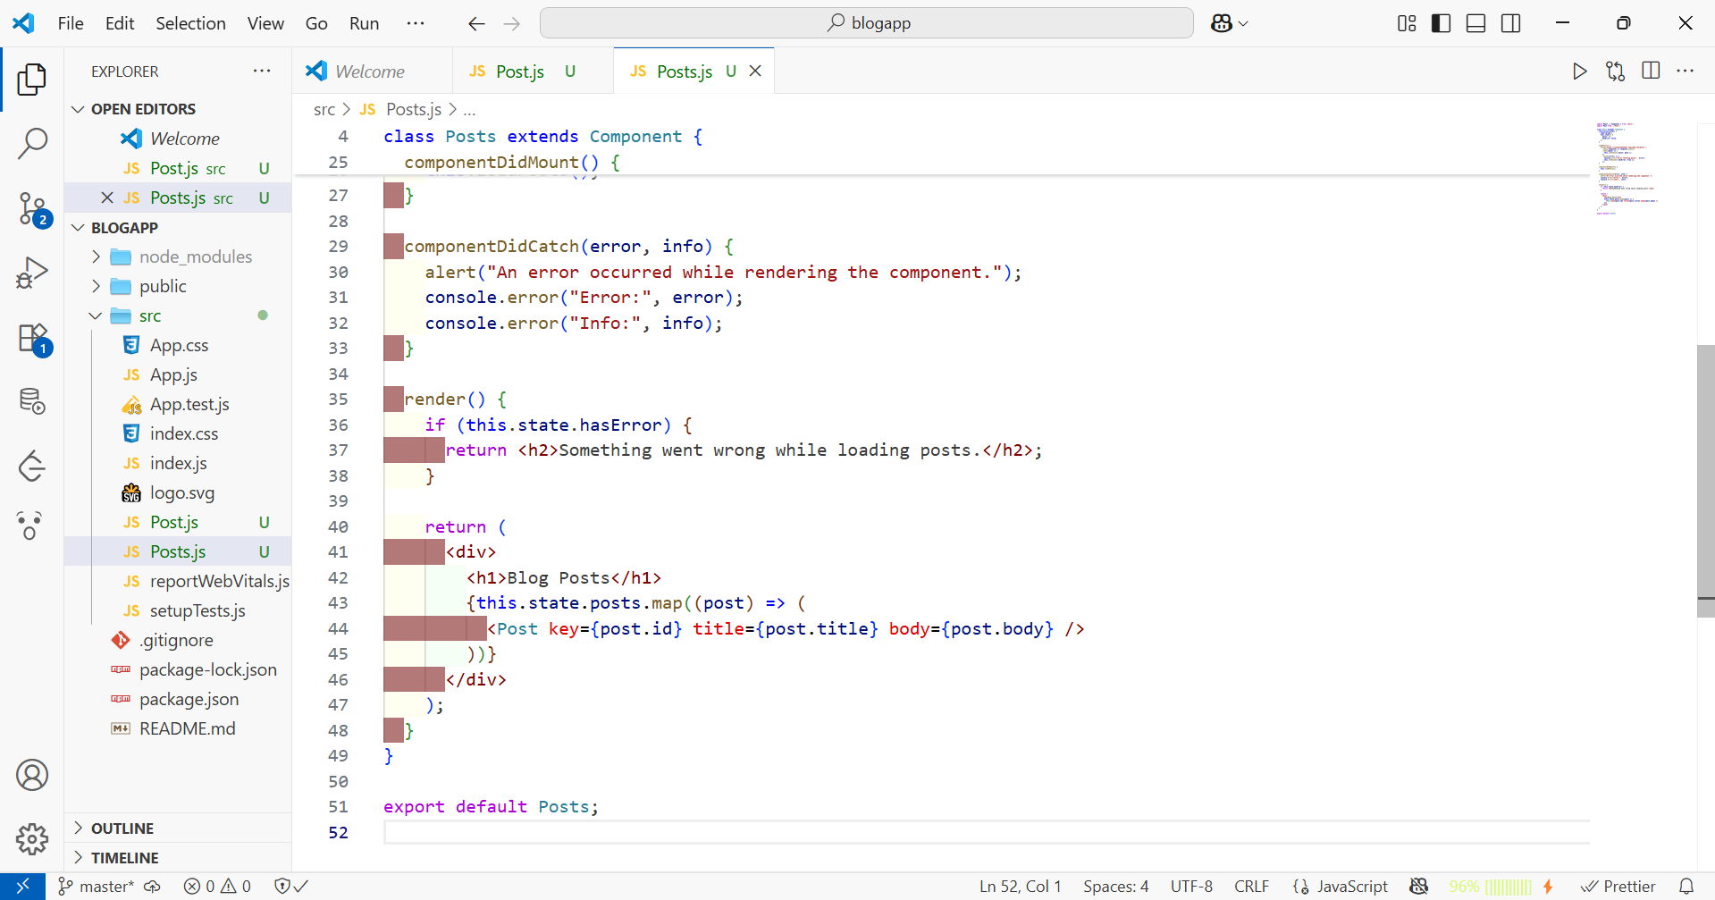

Step4:Editing App.js to add components

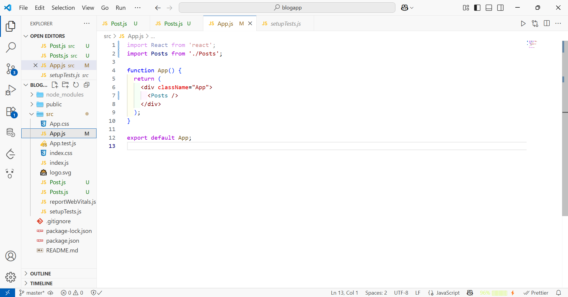

Step5:Starting the React app and viewing it on browser



